**Hotel Booking System**

**Software Requirement**

☺Andy Huang ☻

♪ Patrick Kevorkian ♫

► Can Peng Cai ◄

◄ Steven Kong ►

11/10/2015

**Table of contents**

1. Preface……………………………………………………………………………………..3
   1. Modification History………………………………………………………………3
   2. Intended Audience………………………………………………………………...3
2. Introduction………………………………………………………………………………..3
3. User Requirement Definition……………………………………………………………...4
4. System Requirement Specifications………………………………………………………4
5. System Architecture……………………………………………………………………….4
6. System Models…………………………………………………………………………….7
   1. Use Case Diagrams………………………………………………………………..7
   2. Sequence Diagrams……………………………………………………………….7
   3. Class Diagrams……………………………………………………………………8

**1.Preface**

**1.1 Modification History**

|  |  |  |  |
| --- | --- | --- | --- |
| **Date** | **Version** | **Author** | **Summary of changes** |
| **11/10/2015** | **v1.0** | **All Members** | **Started document** |
| **11/11/2015** | **v1.1** | **All Members** | **Added Table of Contents** |
| **11/15/2015** | **v1.2** | **All Members** | **Added Preface and Intro** |
| **11/16/2015** | **v2.0** | **All Members** | **Added Requirement Deff** |
| **11/17/2015** | **v3.0** | **All Members** | **Added System Requirements Specification and System Architecture** |
| **11/18/2015** | **v4.0** | **All Members** | **Added System Models and Evolution** |
| **11/22/2015** | **v5.0** | **All Members** | **Finished Product** |

**1.2 Intended Audience**

This document is intended for all everyone who is interested in a Hotel Management and Booking system.

**2. Introduction**

The problem that we are trying to solve is to create a program in which we monitor hotel rooms for a client’s company. We will track which rooms are vacant and what food orders the room has out and already closed. We will track the date, time, food orders and overall bill of the stay for checking in, checking out and an overall bill of the stay. This program would be used for hotels which book many rooms throughout their day to day operations. A company that would fit into this category could be a company such as Caesars’ hotel and casino. Their day to day operations include booking rooms and providing room service to customers. Another application for this program would be any motel.. They rent rooms to people for their personal use, recording all necessary information that is needed to book a room.

**3. User Requirement Definition:**

The user requirements are to manage the usage of a database of hotel rooms, to log which are booked, and to manage room service orders for the kitchen.

**4. System Requirement Specifications:**

There will be minimal to no performance/time constraints in the use of the Hotel Booking System. In a real world application the time constraints will only be dependent on the customer and the kitchen staff. Since info is logged to the database almost instantaneously, time is only dependent on the time needed by the user to interact with the interface. While performance is only impacted by the source computer (virtualization, access to the server or hardware of point of access) of the users data is by the computer. Room service orders depend upon how long it takes to make whatever the customer ordered and then get to them. Where checking out a customer can only happen at the end of a customer's stay. While doing these things is no problem for the program, when they are done is dependent upon the customer/kitchen. Implementation constraints will depend on the companies using it. First companies would have to have a database of their employees and their credentials. Second the descriptions of the rooms the particular hotel has would be needed along with a menu for the kitchen. Lastly the actual ability use the program.

**5. System Architecture**

**Public Interface:**

The public interface of the system includes all in which the user will see in order to operate the system effectively. At the most basic, it will only have a few key steps. Firstly, there is an option for an employee to login. He or she must first use their credentials to access the system. Then from here, he or she can use it for booking rooms, or if they are kitchen staff to keep up with room service orders. Finally, a summary of the information logged will be shown, a confirmation will be available and then added to the database. They will be asked all of the required information needed to gain access to a room or order room service. All of which will be accessed through a keyboard and a GUI.

**Database Description:**

The database we will be using will be a MYSQL database based off of the SQL language or “Structured Query Language.” In general we can set up this database anywhere but for the sake of testing we will run it locally. Using a workbench or a command prompt admins can directly manipulate the database without the program for maintenance or to add employees credentials. The database will have a users table that holds all employee credentials, a records table to hold all records of day to day operations, and last a menu table to hold the menu items the kitchen can make for a customer. The program will add and retrieve data using the queries we code into the program and will be run using the built in MYSQL functions in C#.

**Class Dependencies:**

1. Class Employee
   1. this will have all the functions used in Front Deck class and Kitchen Staff class
2. Class Front Desk inherits from Employee
   1. this will be what the Front Desk will be using, this inherits functions from the employee with different parameters for the functions
3. Class Kitchen Staff inherits from Employee
   1. this will be what the Kitchen Staff will be using, this inherits functions from the employee with different parameters for the functions
4. Class Menu
   1. Connect to database and log in then detect if you are a Front Desk employee or if you are a Kitchen Staff employee
   2. If Front Desk
      * 1. Check in customers
           1. edit reservations
        2. check out customers
           1. add final price
        3. check the log
           1. edit the log
        4. check available rooms
      1. If Kitchen Staff
         1. check on room orders
            1. be able to edit the orders
         2. check out the orders
            1. when finished with the order update final price
         3. check the list of orders
            1. edit the list

**6. System Models**

**6.1 Use Case Diagrams**

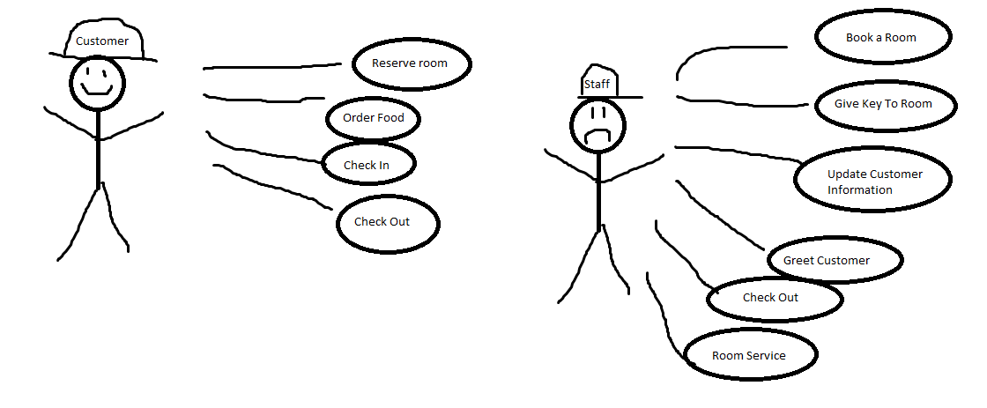

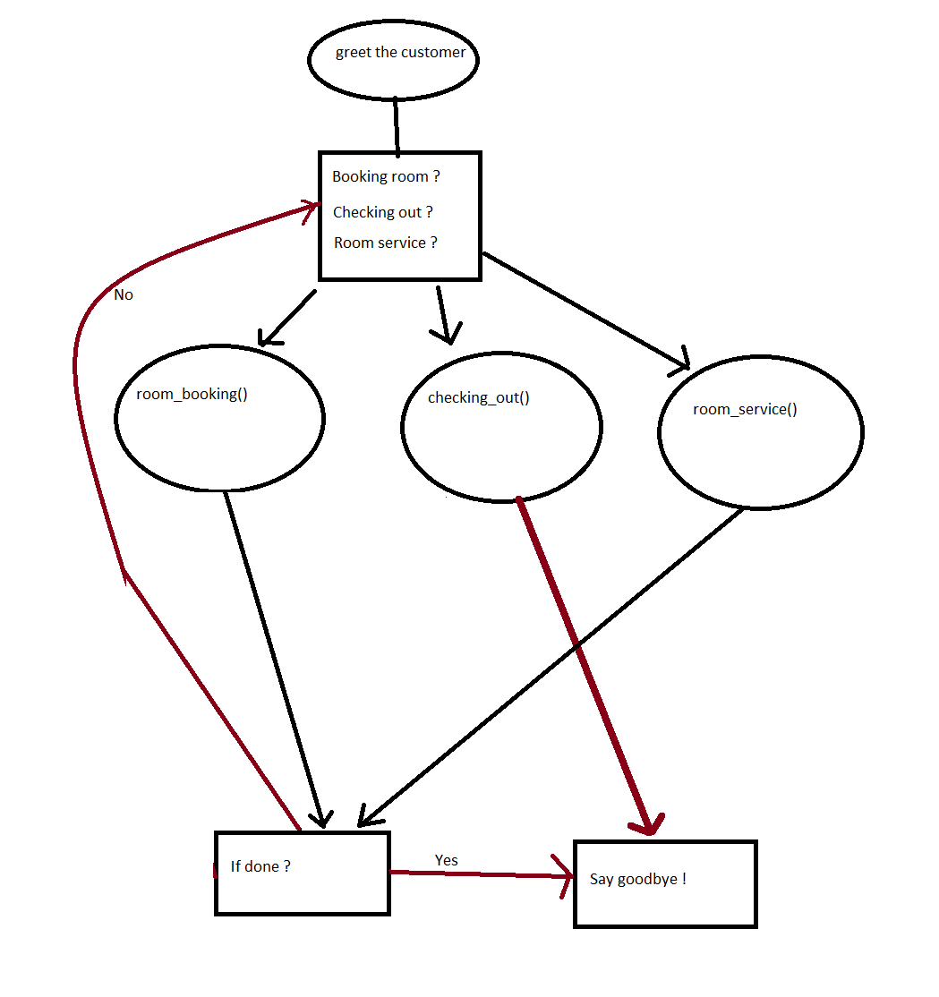

**6.2 Sequence Diagram**

**6.3 Class Diagram**